**Lesson 9 Demo 7**

**Handling Component Failure Threshold**



Steps to be followed:

1. Listing cluster

**Step 1: Listing Cluster**

* 1. Check the nodes in the cluster by executing the following command:

***kubectl get nodes***

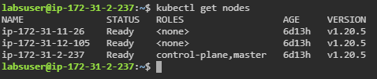

* 1. Check the cluster health information and write into the **dump.json** file using the following commands:

***kubectl cluster-info dump > dump.json***

***vi dump.json***



